How to Amend Offline a booking?
In DOTWConnect, one can do an offline booking amendment through the DOTWConnect system. This means that a team member would need to coordinate with a hotel or supplier with the availability and rates for an amendment request. If and once a client accepts the additional selling price for the amendment, the amendment details and rates can now be manually updated in DOTWConnect, allowing the details to update in the booking and the LPOs.

Once a booking has already been amended offline, the Amend Booking button will no longer be available. Any future amendments will now need to be manually amended with the hotel / supplier and updated in DOTWConnect, via the Offline Amendment functionality.

WHAT IS IMPORTANT TO BE DONE, PRIOR TO AMENDING OFFLINE?
Before processing the Offline Amendment functionality in DOTWConnect, please ensure that the booking has been amended first with the hotel/supplier on their end. This is IMPORTANT to do first, as any offline amendment in DOTWConnect will not reflect on the hotel's/supplier's end.

In addition, please ensure that, if applicable, the customer has accepted any additional rate, if any. Once this is done, the Amend Offline action button can be clicked, located in the lowest part of the DOTWConnect full booking summary.

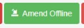

WHAT ARE THE NEW AMENDMENT TYPES NOW POSSIBLE VIA AMEND OFFLINE?
The amend offline functionality has been further developed, to allow additional developments and actions which were previously not possible. Effective February 9th, 2023, the Amend Offline functionality will also now allow the following options:

- Ability to do an amend offline to a booking that is with INVOICED status.
- Ability to do an amend offline to a booking that is with CANCELLED status.
- Ability to change both the cost and selling price to 0.00, for bookings that are pre-travel.
- Ability to allow and reflect compensation amounts to both the supplier cost and selling price.
- Ability to allow a user to enter the cost and selling price for the whole stay, in addition to per night.
- Ability to calculate the mark-up percentage correctly, allowing negative mark-up up to -99.00%
- Ability to enter the cost and selling price to 0.00 on Miscellaneous bookings.
- Ability to calculate the mark-up percentage correctly for Miscellaneous bookings.

WHAT ARE THE TYPES OF AMENDMENTS THAT CAN BE AMENDED OFFLINE?
There are several things that can be updated or amended in the Offline Amendment functionality if these are first coordinated and manually amended on the hotel's/supplier's end. Through Offline Amendment, a user can amend the following:

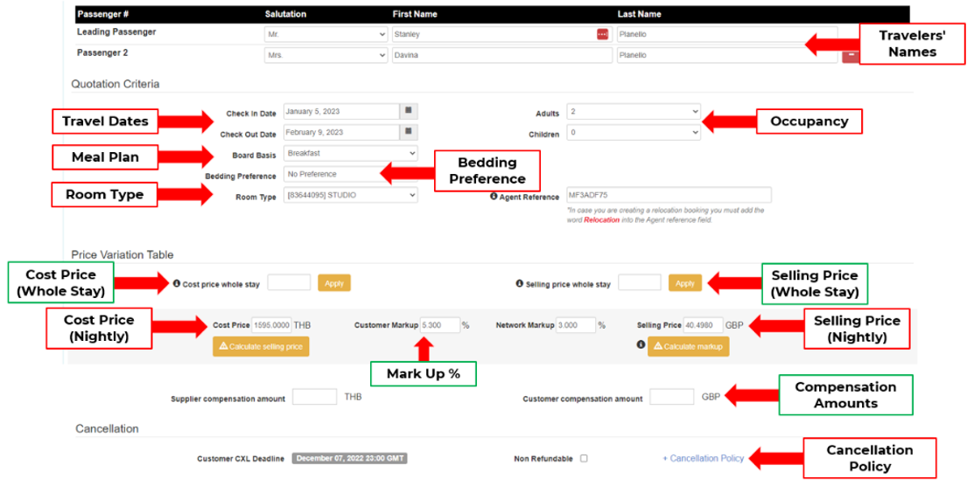
- Name
- Travel Dates
- Occupancy
- Meal Plan (Board Basis)
- Bedding Preference
- Room Type
- Cost Price (Total & Nightly)
- Selling Price (Total & Nightly)
- Mark-up %
- Compensation Amounts
- Cancellation Policy

HOW TO AMEND THE BOOKING DETAILS VIA AMEND OFFLINE?
The top part of the amend offline page will give a user access to amending the booking details, depending on what the customer’s request or need is. Prior to amending the cost and selling price and if the hotel/supplier has given the authorization for us to amend, a user will need to ensure that the appropriate booking detail has been amended first accordingly.

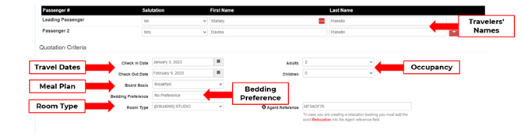

Once the needed booking details has been amended, a user can then scroll down more to proceed to adjust the rates.

If only the cost and selling price would need to be adjusted, a user can immediately scroll down to the Price Variation Table area, which would allow a user to amend the cost and selling price.

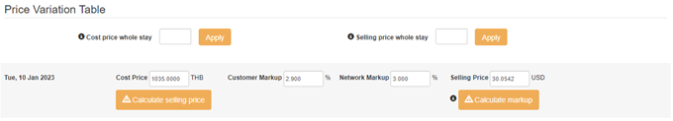

HOW TO AMEND THE COST AND SELLING PRICE VIA AMEND OFFLINE?
DOTWConnect’ s Amend Offline functionality allows a user to make both Cost and Selling Price Amendments, lessening the need to create manual LPOs or miscellaneous bookings. There are several types of price amendments that can be done in the Amend Offline functionality.

AMENDING THE COST AND SELLING PRICE VIA THE WHOLE STAY’s RATE

If a hotel or supplier has given the new booking cost for the whole stay and the nightly rate for all nights are equal and same, the Amend Offline functionality now allows the:

Ability to enter the cost and selling price via the whole stay’s cost/price, and
Ability of the system to automatically divide the cost and selling price equally, dependent on the number of nights

Once the whole stay’s cost has been received and the whole stay’s selling price has been calculated, a user will need to enter the whole night’s cost in the “COST PRICE WHOLE STAY” box. The whole night’s selling price will need to be entered in the “SELLING PRICE WHOLE STAY” box.

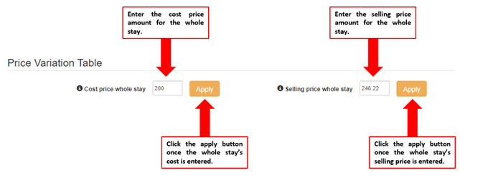

Once the whole stay’s cost price and selling price is entered, a user will need to click on the apply button to allow the system to equally divide the whole stay’s cost and selling price, based on the number of nights of the booking.

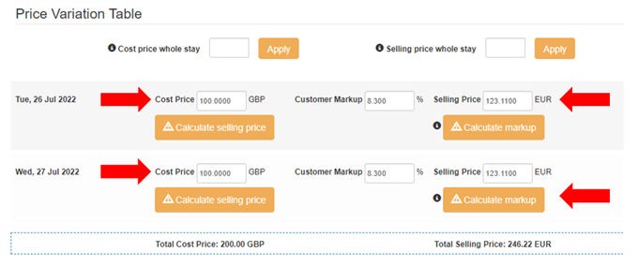

AMENDING THE COST AND SELLING PRICE PER NIGHT AUTOMATICALLY

A user will have an option to change the cost and selling price per night automatically. To do this, a user will need to enter the new value of the booking cost in the respective nightly “COST PRICE” box. Afterwards, the “CALCULATE SELLING PRICE” button will need to be clicked, to allow the automatic calculation of the selling price based on the default mark-up.

There will be no need to click on the “CALCULATE MARKUP” button anymore, on these scenarios.

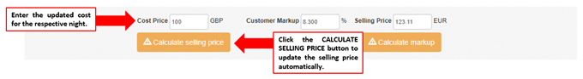

AMENDING THE SELLING PRICE BASED ON AN ADJUSTED MARK-UP %

A user will have an option to calculate the selling price, based on an adjusted mark-up %. This scenario may happen if there is authorization by the Sales/Business Development Manager or by your respective Operations Managers.

To do this, a user will need to enter the new value of the booking cost in the respective nightly “COST PRICE” box. Afterwards, the CUSTOMER MARK-UP box will need to be adjusted to the approved adjusted mark-up by the Sales/Business Development Manager or OPS Manager.

A user can click on anywhere else in the page or click on the “CALCULATE SELLING PRICE” button to allow the selling price to be automatically calculated, based on the adjusted mark-up. This needs to be done for all nights that would need to be adjusted.

There will be no need to click on the “CALCULATE MARKUP” button anymore on this scenario, as the user manually input the adjusted mark-up in the box.

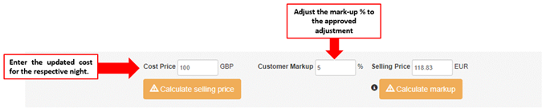

ADJUSTING THE SELLING PRICE AND MARK-UP % MANUALLY

The current amend offline functionality allows a user to input a specific selling price and adjusting the mark-up % manually. To do this, a user will need to enter the new value of the booking cost in the respective nightly “COST PRICE” box.

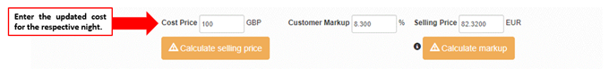

The user will, then, need to enter the updated selling price for the respective night in the “SELLING PRICE” box. Once done, the CALCULATE MARKUP button will need to be clicked, to allow the system to adjust the mark-up % automatically. This needs to be done for all nights that would need to be adjusted.

In this example, we can see that the mark-up %, after clicking the Calculate markup button, has increased to 43.55%, compared to the original 8.30%.

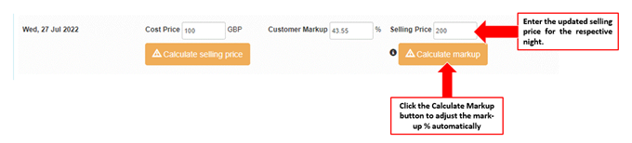

In this scenario, there is no need to click on the “CALCULATE SELLING PRICE” button anymore on this scenario, as the user manually input the adjusted selling price.

AMENDING ONLY THE BOOKING COST

AMENDING ONLY THE BOOKING COST FOR ALL NIGHTS

If a user will need to adjust only the booking cost, a hotel or supplier has given the new booking cost for the whole stay and the nightly rate for all nights are equal and same, a user a user will need to enter the whole night’s cost in the “COST PRICE WHOLE STAY” box. The system will automatically divide the whole stay’s booking cost, dependent on the number of nights.

There is no need to enter or apply a new selling price whole stay, as only the booking cost needs to be amended.

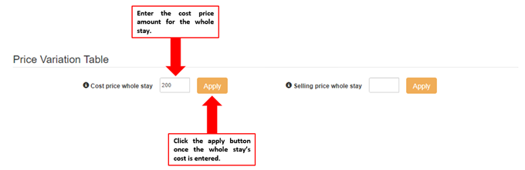

AMENDING ONLY THE BOOKING COST PER NIGHT

If a user will need to adjust only the booking cost on a per night basis, a user will need to enter the new value of the booking cost in the respective nightly “COST PRICE” box.

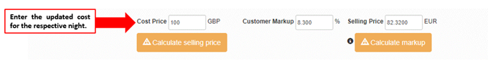

There is no need to click on the Calculate Selling Price button or Calculate Markup button, in this scenario, as there will be no changes to these values.

AMENDING THE COST AND PRICE IF THERE ARE DATE CHANGES

If the amendment offline is due to a change in travel dates, the Price Variation table section will update to add new or additional nightly cost and price rows, based on the new or additional travel dates.

A user will need to input the booking cost for the new or updated nights for the booking in the “COST PRICE” boxes. Afterwards, the “CALCULATE SELLING PRICE” button will need to be clicked, to allow the selling price to automatically be calculated. This needs to be done for all new or additional nights in the booking.

There will be no need to click on the “CALCULATE MARKUP” button anymore, on these scenarios.

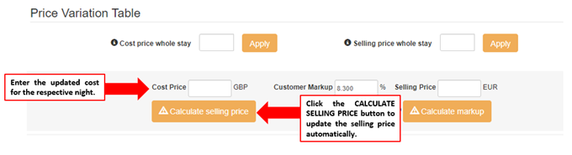

HOW TO ENTER CUSTOMER COMPENSATION AMOUNTS FOR AN ACTIVE BOOKING

If a user will need to give an approved compensation amount to a customer and a booking is still active, this can be done via the Amend Offline functionality.

For example, if a customer needs to be given an approved compensation and the compensation is a one-night stay, what a user will need to do is to adjust the “SELLING PRICE” box to 0.00. Afterwards, a user will need to click on the “CALCULATE MARKUP” button to adjust the mark-up % for that specific night.

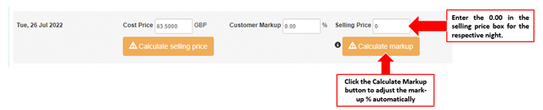

If for example, a customer needs to be given an approved compensation of a specific amount above 0.00 (ex: EUR 10.00), what a user will need to do is to deduct the approved compensation amount in the “SELLING PRICE” box. Afterwards, a user will need to click on the “CALCULATE MARKUP” button to adjust the mark-up % for that specific night.

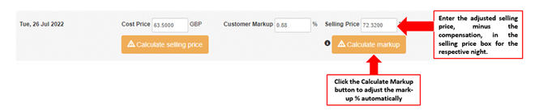

HOW TO ENTER COMPENSATION AMOUNTS TO A BOOKING THAT WOULD NEED TO BE CANCELLED

There are situations wherein a customer will request for the booking to be cancelled and request for compensations per contract, usually due to an In-Resort relocation that is not able to be accommodated within the contracted time.

A CS team member will need to coordinate with: a. the hotel to get the authority for a full refund and b. his/her manager/director to request approval for the compensation amount. Once both authorizations have been received, a CS team member would need to cancel the booking via CANCEL OFFLINE and keep the cancellation charges.

Once the booking is cancelled with charges via CANCEL OFFLINE, the CS team member will now need to go to the Amend Offline functionality to adjust the rates.

A user will, first, need to ensure the both the cost price and selling prices for all nights in “0.00.” To do this, a user will need to enter “0.00” in the “COST PRICE WHOLE STAY” box. The whole night’s selling price will need to be adjusted to "0.00” in the “SELLING PRICE WHOLE STAY” box, as well.

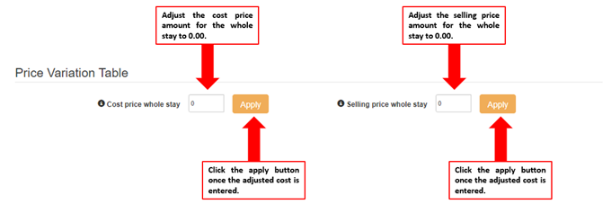

Once the whole stay’s cost price and selling price is adjusted to 0.00, a user will need to click on the apply button to allow the system to apply the adjusted rate to all nights. Once all night’s cost and price are showing as “0.00,” the “CUSTOMER COMPENSATION AMOUNT” box in the lower part of the page will now be opened for adjustment.

A user will need to enter the compensation amount that needs to be given to the customer, in this box.

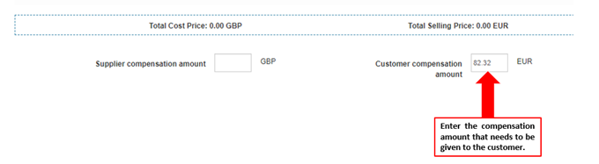

HOW TO ENTER COMPENSATION AMOUNTS TO AN INVOICED BOOKING

If a user will need to give an approved compensation amount to a customer and a booking is already with an invoiced status, this can also now be done via the Amend Offline functionality. This will be most helpful in cases of relocations.

Once a CS Team member has received the supplier authority and the approval of the manager/director for compensation, the team member will need to ensure the both the cost price and selling prices for all nights in “0.00.” To do this, a user will need to enter “0.00” in the “COST PRICE WHOLE STAY” box. The whole night’s selling price will need to be adjusted to "0.00” in the “SELLING PRICE WHOLE STAY” box, as well.

Once the whole stay’s cost price and selling price is adjusted to 0.00, a user will need to click on the apply button to allow the system to apply the adjusted rate to all nights. Once all night’s cost and price are showing as “0.00,” the “CUSTOMER COMPENSATION AMOUNT” box in the lower part of the page will now be opened for adjustment.

A user will need to enter the compensation amount that needs to be given to the customer, in this box.

HOW TO CHANGE THE CANCELLATION DEADLINE VIA AMEND OFFLINE?
If the cancellation deadline needs to be amended after doing a manual amendment with a hotel, this can be done via the Offline Amendment functionality. Click on the blue "+ Cancellation Policy" link in the right, so that the cancellation policy can be adjusted accordingly.

If there are no changes to the cancellation deadline, this can be left as is.

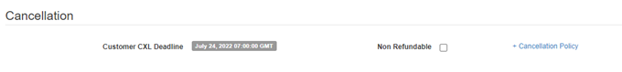

HOW TO SEND AN UPDATED LPO TO THE SUPPLIER OR CUSTOMER AFTER AMENDING OFFLINE?
Once one has processed an Offline Amendment, there will be a choice to choose if the updated LPO/Booking Confirmation to be sent to the supplier and/or customer after doing an offline amendment. By default, these choices are placed as YES.

However, for example, if the rate will be amended because of an error on our end, one can choose YES to "Send Email to Supplier" but NO to "Send Email to Customer." The system will also allow you to send the LPO to a different email address, than what we have on file.

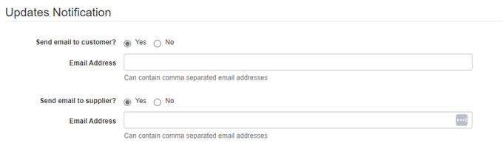
Note: Email Addresses in the above picture removed for security purposes

Please note that the Send Email to Supplier row will only be available, if the booking is taken from a Direct Contract or Channel Manager booking channel.

HOW TO COMPLETE THE AMENDMENT OFFLINE?
There will be a reminder at the end of the page that this is an Offline Amendment. This is a reminder to the user that this first needs to be coordinated with the supplier and that the amendment should authorized or done in the supplier’s end first, before amending it in DOTWConnect Amend Offline. The tick box can be clicked if the amendment has been coordinated with the supplier first.

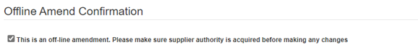

Once all actions above are done, clicking the “SAVE OFFLINE” button will complete the process of Offline Amendment.

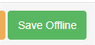

If a booking is payable via VCC, the virtual credit card information and amount will automatically be updated. However, if a booking is payable via bill back, the monthly invoice will be adjusted accordingly - based on the new information.

WHEN TO REACH OUT TO THE FINANCE TEAM, ONCE AN AMEND OFFLINE IS DONE
The need to reach out to the Finance team will depend on when the travel date of the booking is and when the amendment offline was made.

IF BOOKING IS PRE-TRAVEL AND AT LEAST ONE DAY BEFORE CHECK-IN

If a booking is pre-travel and at least one day before the check-in date, there is no need to reach out to Finance team to notify them of the changes we have made. Any rate adjustments due to Amend Offline will automatically reflect in the financial system once amended. The VCC amount is automatically adjusted, as well.

IF BOOKING IF PRE-TRAVEL BUT IS ALREADY ON THE DAY OF CHECK-IN

DECREASE IN RATES/REFUNDS

The Customer Service team member no longer needs to reach out to the Finance team to notify them of the changes made. These rate adjustments due to Amend Offline will automatically reflect in the financial system, once amended. It is, however, very important that the hotel/supplier has given written authority and this document can be pulled in via Freshdesk.

INCREASE IN RATES/UPGRADES

Once the Amendment Offline, leading to an increase in rate, is processed, the Customer Service team member will need to send an email to the appropriate VCC team email address to notify them of the amendment offline done and to create a new VCC, as needed.

IF BOOKING IS PAST THE CHECK-IN DATE/STATUS IS INVOICED

DECREASE IN RATES/REFUNDS

The Customer Service team member no longer needs to reach out to the Finance team to notify them of the changes made. These rate adjustments due to Amend Offline will automatically reflect in the financial system, once amended. It is, however, very important that the hotel/supplier has given written authority and this document can be pulled in via Freshdesk.

INCREASE IN RATES/UPGRADES

Once the Amendment Offline, leading to an increase in rate, is processed, the Customer Service team member will need to send an email to the appropriate VCC team email address to notify them of the amendment offline done and to create a new VCC, as needed.

